**Network Task**

**Task Description:**

1.Get me the IP address of a particular domain (guvi.in). How do I find my CPU/memory usage of my server? Test the connectivity between 2 nodes?

**# IP address of a particular domain (guvi.in):-**

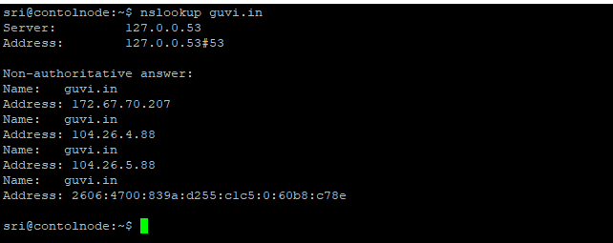

**# find my CPU/memory usage of my server**

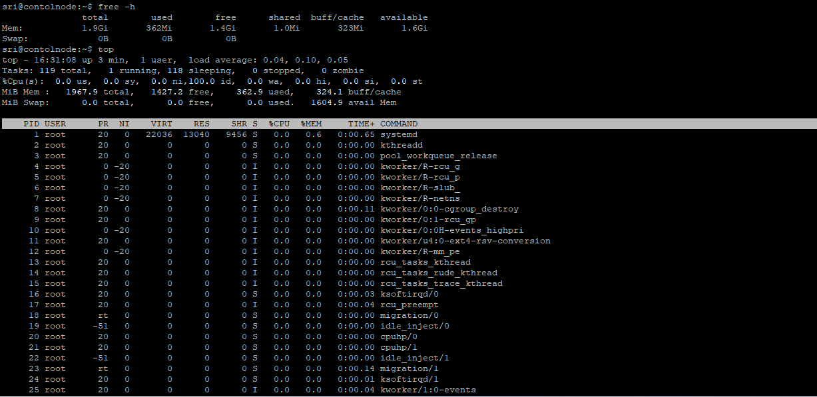

**#** **Test the connectivity between 2 nodes**

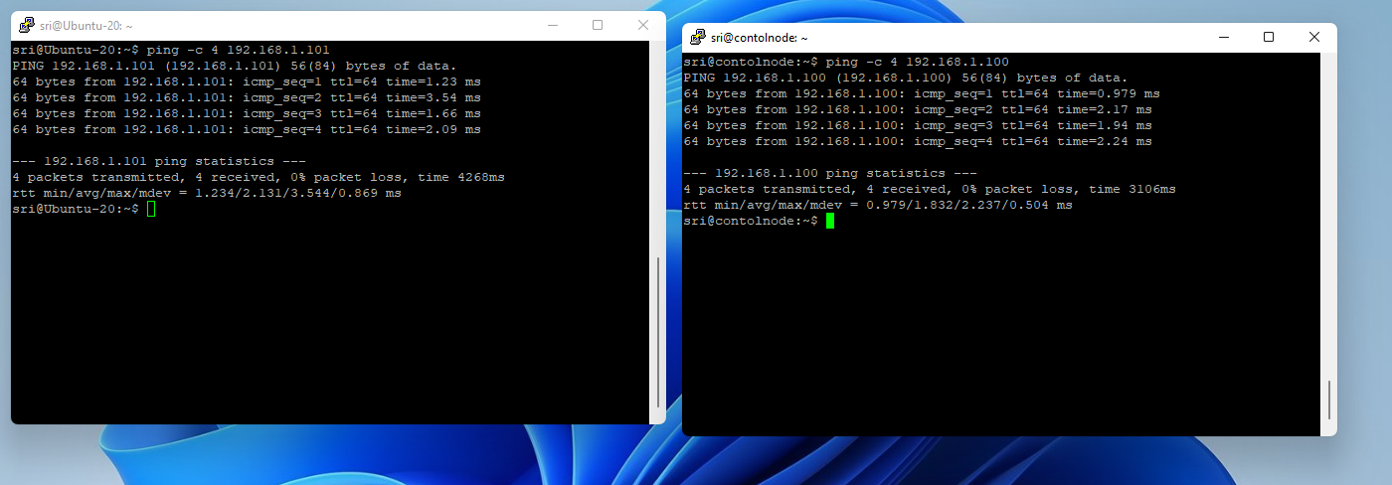

2.I have deployed an application in guvi.com:9000, and logs show my app is running, but I’m unable to view the page. Check whether my port is open or not ?

**# Check whether my port is open or not**

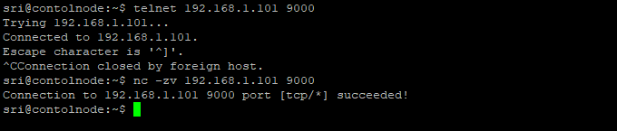  
  
**Example application working status:**   
  
